

**“SDA”**

**Submitted To:**

**SIR MUKHTIAR ZAMIN**

**Submitted By:**

**MURTAZA TANVEER**

**Reg No:**

**SP23-BSE-096-5B**

**Use Case Diagram:**

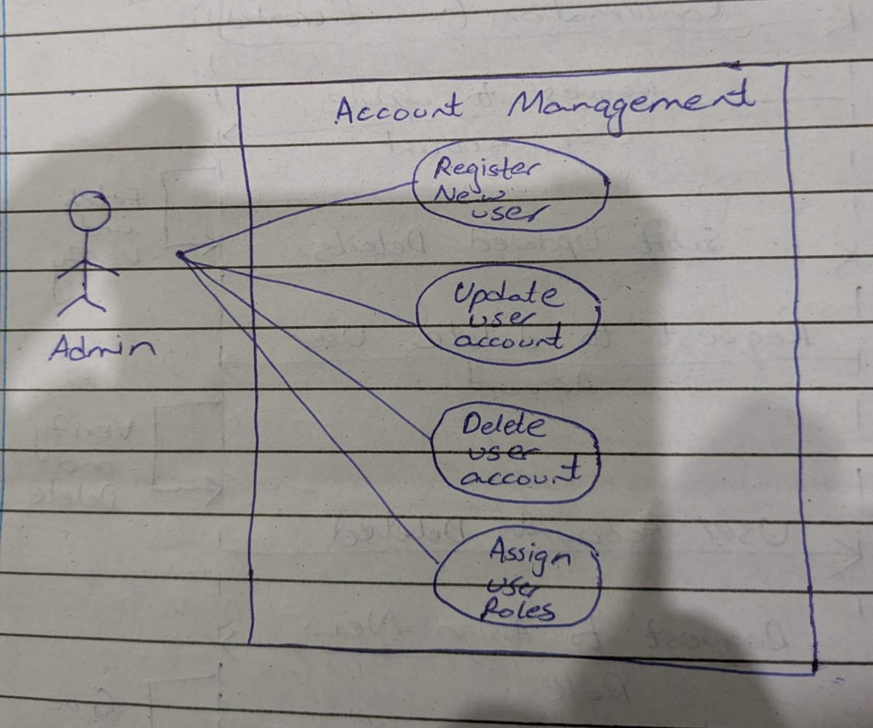

**System Sequence Diagram:**

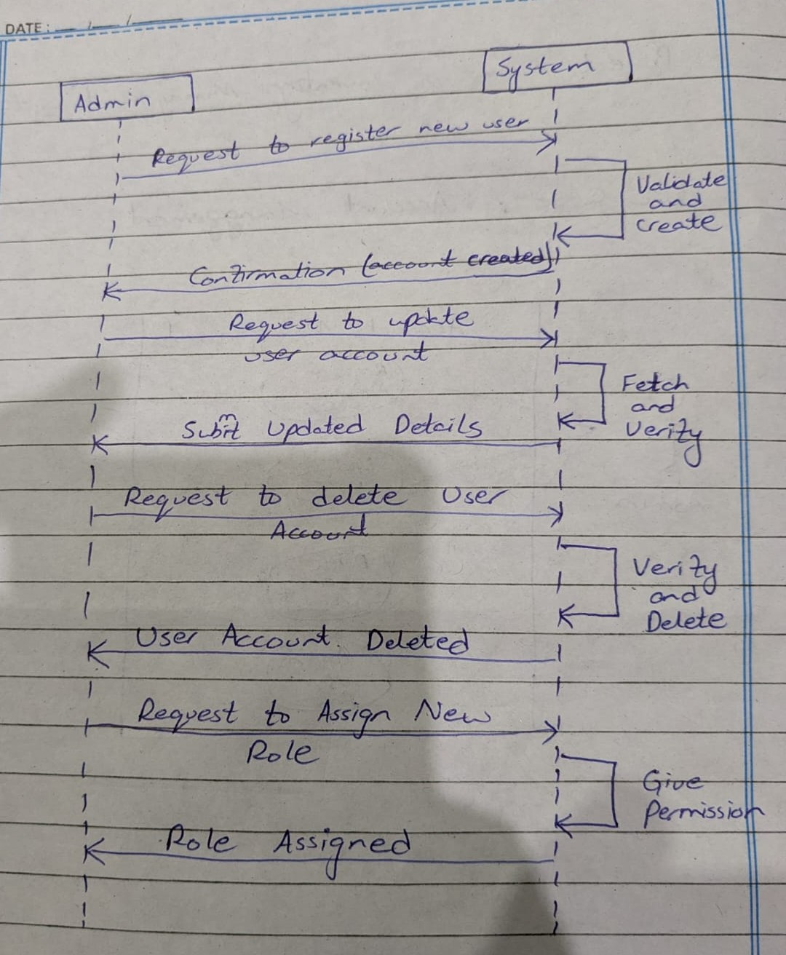

**Package Diagram:**

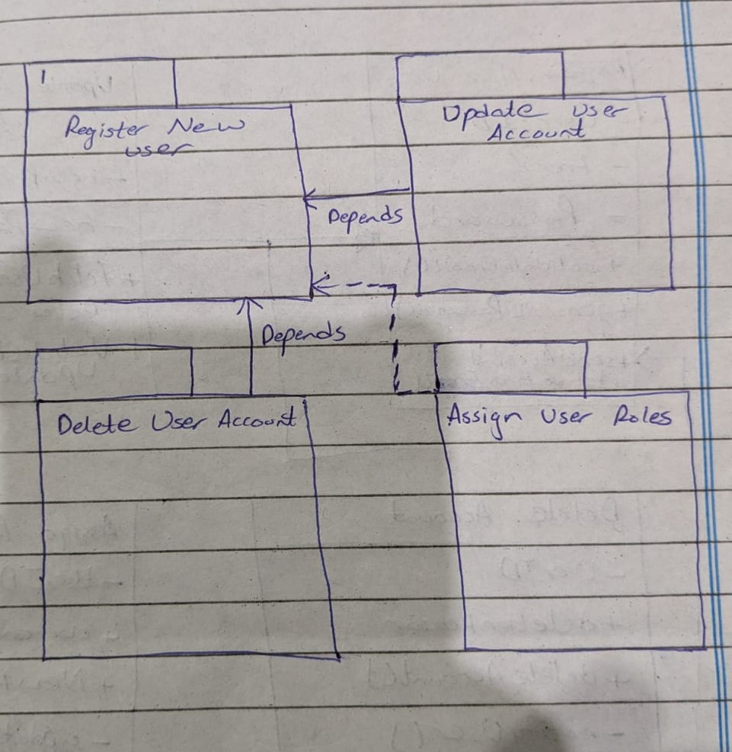

**Class Diagram:**

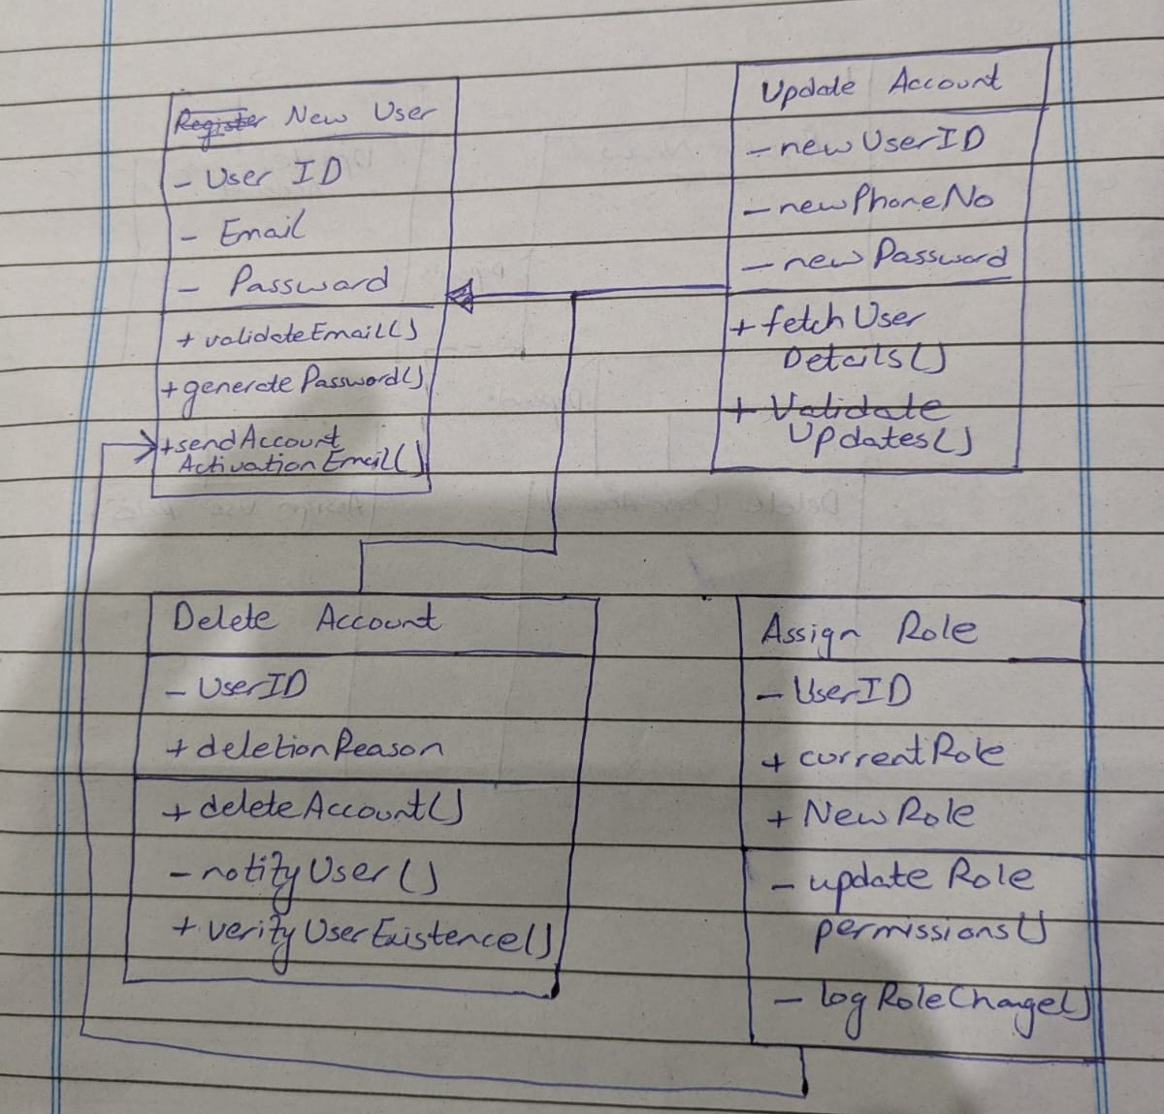

**Full Dresses Use Cases:**

**Primary Actor:** Admin

**Secondary Actors:** System, Email Service

**Preconditions:**

Admin is logged in with sufficient privileges.

System is operational.

**Main Success Scenario:**

1. Admin selects an account management action (Register/Update/Delete/Assign Roles).
2. System displays the relevant form based on the action:

Register New User: Name, email, role fields.

Update User: Editable fields (e.g., name, email).

Delete User: Confirmation dialog.

Assign Roles: Role dropdown list.

1. Admin enters required details and submits the request.
2. System validates inputs:

For registration: Checks email uniqueness.

For updates: Verifies user exists.

For deletion: Confirms no active dependencies.

For role assignment: Ensures admin has permission.

1. System processes the request:

Creates/updates/deactivates the user account or updates roles.

Sends notifications (e.g., welcome email for new users).

1. System confirms success to the Admin.

**Postconditions:**

* For registration: New user is added to the system.
* For updates: User details are modified.
* For deletion: User account is deactivated/removed.
* For role assignment: User permissions are updated.